

|  |  |
| --- | --- |
| Date | 12 November 2022 |
| Team Id | PNT2022TMID492 0 |
| Project name | Hazardous area monitoring for Industrial plant powered by IoT |

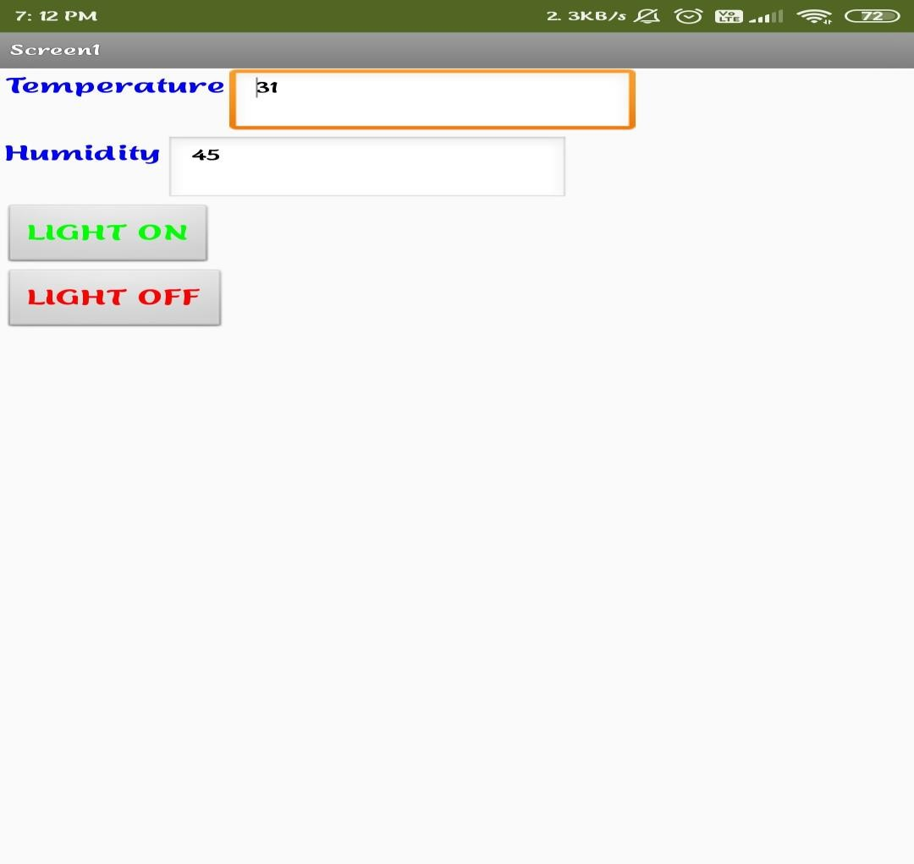**Configure the mobile app for controlling motor using button:**

Configure the mobile app for controlling motor using button creating successfully